**CP Club 365Days Challenge**

**Programming language – C++**

**Problem Statement**

[https://practice.geeksforgeeks.org/problems/run-length-encoding/1?page=1&difficulty[]=0&category[]=Strings&sortBy=submissions](https://practice.geeksforgeeks.org/problems/run-length-encoding/1?page=1&difficulty%5b%5d=0&category%5b%5d=Strings&sortBy=submissions)

**Your Code**:

// 0x62Day of 0x365Days challenge

// VEDANT BHARAD

// 18-12-2022

//{ Driver Code Starts

#include <bits/stdc++.h>

using namespace std;

string encode(string src);

int main() {

    int T;

    cin>>T;

    while(T--)

    {

        string str;

        cin>>str;

        cout<<encode(str)<<endl;

    }

    return 0;

}

// } Driver Code Ends

/*You are required to complete this function */

string encode(string src)

{

    // Your code here

    string toret;

    int i=0;

    while(src[i]!='\0')

    {

        char temp= src[i];

        int loop2=i,con=0;

        while(src[loop2]==temp)

        {

            con++;

            loop2++;

        }

        toret=toret+temp;

        ostringstream str1;str1 << con;

        toret=toret+str1.str();

        i=loop2;

    }

    return toret;

}

**Output (Screen Shot)**:

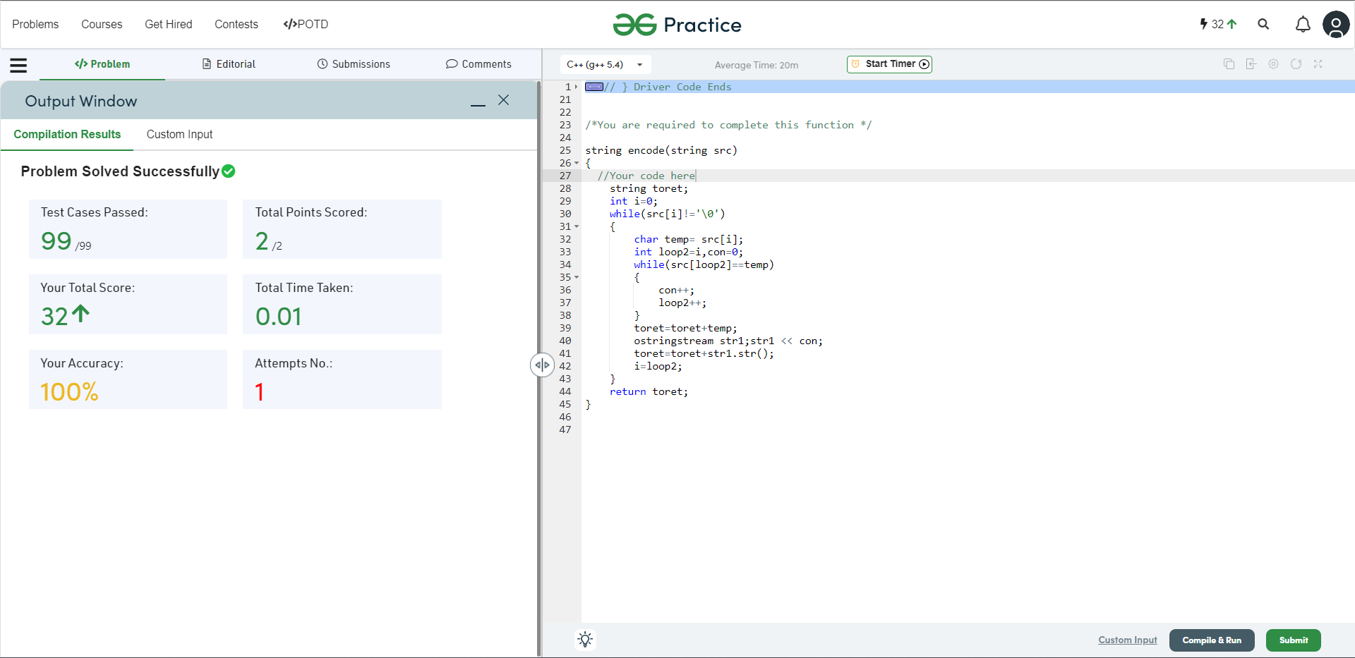

**Understanding about problem:**

* In this task I need to return a string in that there will be each char and count of that char’s frequency.

Note: If you can't understand the problem, feel free to contact us and we'll help you. Please don't copy and paste from anywhere.

ALL THE BEST

Team CP Club